How to create audio (MP3) files for use within A2J Author

Access to Justice Author (A2J Author) allows you to attach audio to each question, to each question help bubble, and also to pop-up bubbles. A2J uses audio files in MP3 format. This manual describes the recommended method for (1) recording, (2) editing, (3) creating, and (4) attaching MP3 files to A2J dialogs.

- Recording the audio for an A2J Interview

Many different software products can be used to record audio, edit, and convert it to MP3 format. This manual describes how to use Audacity. Audacity is free, open source software for recording and editing sounds. It is available for Mac OS X, Microsoft Windows, GNU/Linux, and other operating systems.

  - Setting up and configuring Audacity
    - First, in order to properly run the Audacity software make sure that the computer you are using has the following:
      - Sound card
      - Microphone jack & microphone (you’ll need to plug in a microphone to record the audio)
      - At least 2 GB of hard drive space

    - Download and install the Audacity application. Audacity can be downloaded from:
      - http://audacity.sourceforge.net/

    - Next, before using the Audacity application, you need to download what is referred to as an “MP3 encoder.” Because of software patents, Audacity cannot distribute MP3 encoding software within the application. The Mp3 encoder is what allows Audacity to record directly to MP3 file formats.

      - The most common free MP3 encoder is called LAME. Follow these steps to download and install the LAME MP3 encoder:

        - Download LAME by clicking on the following link
          - http://rarewares.poskolio.com/lame3.97a10.zip
          - The file that you downloaded is a ZIP file which means it’s compressed. Use a utility like WinZip to extract the zip file.

        - Unzip or extract the zip file to the directory where Audacity was installed
          - For example: C:\Program Files\Audacity\

    - Now launch the Audacity application. To configure Audacity to use the Mp3 encoder, follow these steps:
      - Click File Menu → Preferences…
      - In the Audacity Preferences dialog box, click on the third tab that says “file formats” (see screen shot below)
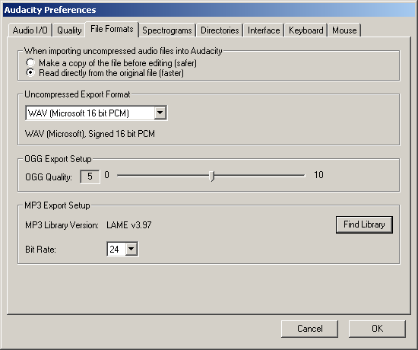

      - Now click on the button that says “Find Library” and browse to the location where you extracted the LAME files.
        - Select “lame_enc.dll”
        - Now select a Bit Rate of 24 as shown in the picture above.
        - If you’ve done it correctly, the Mp3 Export Setup section will look like the picture above.

      - Now, while you still have the Audacity Preferences dialog box open, select the second tab that says “Quality”
        - Set the Default Sample Rate to 11025 Hz. Leave all other settings.
          - See the screen shot below.

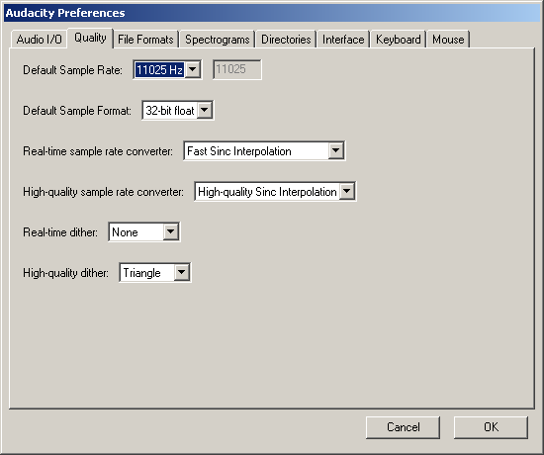

    - Click OK to exit back to the main Audacity program

  - Testing your Recording setup
    - Plug your microphone into the computer
    - Make sure that the microphone is selected as the input device
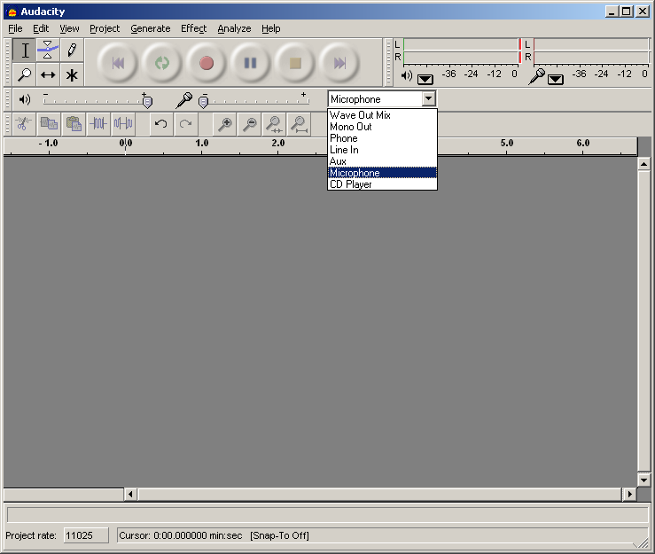

    - Test by clicking on the record button (red Circle)
      - say a few words then click stop (yellow square)
      - Click play to make sure that you can hear what was just said.
  - Recording Audio
    - In A2J Author click on the Report button along the left hand side of A2J Author and then press the “Script” button. This will produce all of the portions of your interview that needs to be recorded. Printing this out will give you a script of everything that needs to be recorded.
    - Record your interview audio → Master Audio Recording
      - Read the entire script of your interview while recording as you want each question to be played in A2J. You will edit the audio into separate files in the next step

- Editing

You should have finished recording the entire script for your A2J Interview. In this step, you will edit the master recording to produce several audio files – breaking the master up into the audio for each individual question.

  - You should have one long master audio recording. Audacity will look something like this:

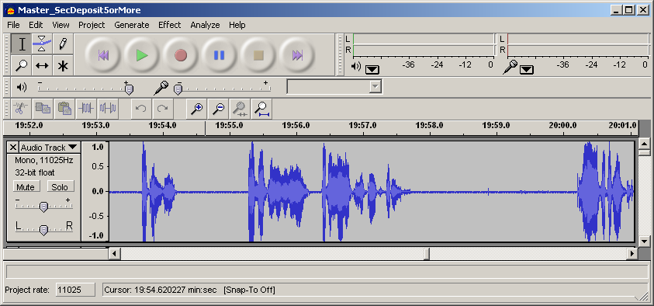

  - Remember to save your work in audacity.
  - Now listen to the recording
    - With a copy of the audio script in hand press play to start listening to your recorded audio
    - When a complete item has been read press stop and highlight the audio that corresponds to a single portion of the script
    - Press “control D” to create a copy of the selected text
    - Scroll down to the bottom of the audacity window and find the audio clip that you just copied

    - Left click on the “Audio Track” which is on the left hand side of your track and select “Name…”

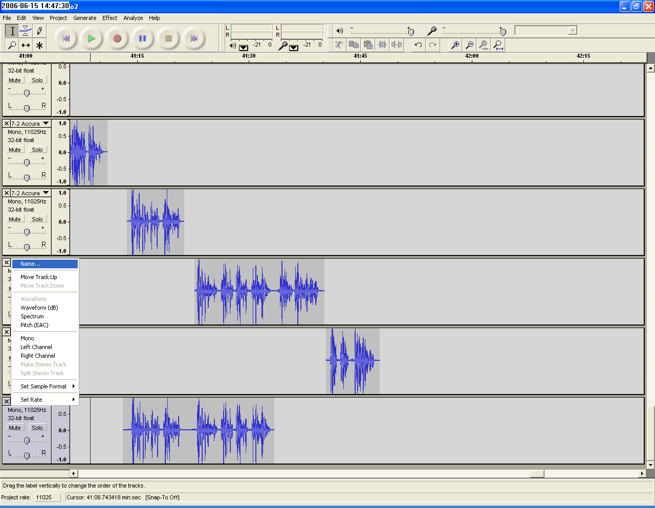

    - Enter a name which corresponds to this audio clip. This name will be the audio clip’s filename when the track is exported
    - Press play to continue and continue this process until you have audio clips for the entire interview. Remember to save often to avoid losing your work.

  - Export the audio clips
    - In the directory where you created your A2J Guided Interview create a folder called mp3
    - In the “File” menu select “Export Multiple…”
    - Select mp3 as the “Export format”

    - Press the “Choose…” button and navigate to the mp3 folder that you created in your interview’s folder.

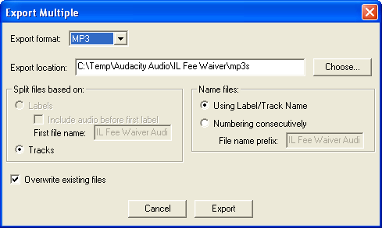

    - Press “Export” and then “OK”
    - When audacity is finished exporting your mp3s, you will have one mp3 file for each track.

- Attaching audio to your A2J Guided Interview
  - Open your A2J Guided Interview
  - In each question add audio to the question’s text and any help or popup text that the question has.
  - To attach a file click on the folder above the question’s, help’s or popup’s text. The folder looks like this:
  - You can test your mp3 file once it is attached by pressing the play button to the left of the mp3 file’s location. The play button looks like this: 
  - Continue adding mp3 files to all of your questions

.

